**Booked BV**

**URS**

**Name:** Steven Chen

**Class:** S2-CB02

**Date:** 09-06-2023

**Version:** 1.4

**Contents**

**1.** **Introduction** 3

**2.** **Agreement with client** 4

**3.** **Functional requirements** 5

**Desktop application:** 5

**Web application:** 5

**4.** **Use cases** 7

**Desktop application** 7

**Web application** 11

**5.** **GUI** 17

**Wireframes** 17

**Desktop application** 21

**Web application** 25

# **Introduction**

The purpose of the User Requirements Specification document is to give the stakeholders an overview of the expected functionalities and requirements for the applications that are going to be made. The document will outlines what agreements were made with the stakeholders during the meetings.

Furthermore in this URS document, it will provide all the functional requirements of the desktop and web application in detailed. These functional requirement is to provide the stakeholders on what to be expected as the final features for the web and desktop application.  
  
In addition, the document will also provide the Use Cases for the functional requirements.   
The Use Cases will describe the interactions and workflows between the end-user (customer or admin) and the applications itself. By providing these Use cases, it will show what are the expected interaction between the application and the end-user.

# **Agreement with client**

During the meetings with the client (John Smith), we discussed about the necessity that the company wants and ask question to the client on how he want the product to look like.   
In the meetings the client told us that the main priority is to get a website where client can book a flight or hotel and a desktop application to manage them.

Therefore we have decided upon for the entire semester to work on these 2 application as the main priority. Additional feature to improve the application could be added if there is enough time, but the main feature will be the priority. The main features of these application will be further explained in this document and the uses for them.

# **Functional requirements**

For these applications there are 2 actors which consist of the clients which here is referred to as the “User” and the administration where they add content to the website which is referred to in these functional requirements and Use Cases as the “Admin”.

## **Desktop application:**

**ID: FR-1**

Name: Admin can view a list of hotels

**ID: FR-2**

Name: Admin can search for a hotel

**ID: FR-3**

Name: Admin can add a new hotel for the website

**ID: FR-4**

Name: Admin can delete a hotel

**ID: FR-5**

Name: Admin can update information on a hotel

**ID: FR-6**

Name: Admin can view all a list of flights

**ID: FR-7**

Name: Admin can search for a flight

**ID: FR-8**

Name: Admin can add a new flight for the website

**ID: FR-9**

Name: Admin can delete a flight from the website

**ID: FR-10**

Name: Admin can update the information on a flight

## **Web application:**

**ID: FR-11**

Name: User can make an account

**ID: FR-12**

Name: User can log in

**ID: FR-13**

Name: User can change their personal information

**ID: FR-14**

Name: The user can see a history of all bookings made

**ID: FR-15**

Name: User can view details of the booking

**ID: FR-16**

Name: User can search for hotels

**ID: FR-17**

Name: The user can go to the details page of the hotel

**ID: FR-18**

Name: User can add a review on a hotel

**ID: FR-19**

Name: User can edit their own review

**ID: FR-20**

Name: User can delete their own review

**ID: FR-21**

Name: User can book a hotel

**ID: FR-22**

Name: User can search for flights

**ID: FR-23**

Name: The user can go to a detailed page of the flight

**ID: FR-24**

Name: User can book a flight

# **Use cases**

**Desktop application:**

**ID: UC-1 (FR-1, FR-2)**

Use Case: Search for hotel

Actor: Admin

Main Success Scenario:

1. User click on Hotels in the side navbar and display a list of all hotel
2. User writes the name of the hotel
3. Click on the “Search button”
4. Display the content

Extensions:

3a. No content is found

1. Display nothing on the list
2. Return to MSS 1

**ID: UC-2 (FR-3)**

Use Case: Add hotel for the website

Actor: Admin

Main Success Scenario:

1. Admin clicks the "Add hotel” button.
2. Admin fills in the details of the hotel that is going to be added to system.
3. Hotel has been added to the website.
4. Display message that hotel is added

Extensions:  
3a. Any required field details are missing

1. Displays a message about field is missing  
2. Return MSS 2

**ID: UC-3 (FR-1, FR-4)**

Use Case: Remove hotel content

Actor: Admin

Main Success Scenario:

1. Display a list of all the hotels
2. Select a hotel from the list
3. Admin clicks the Remove button
4. System shows a warning message about confirming the removal of the content
   1. Trigger: Confirm removal is triggered
5. Selected hotel is removed

Extensions:

3a. No content is selected

1. System displays a message about no hotel is selected
2. Return to MSS 2

4a. Selected 'Cancel' on warning message about confirming the removal

1. System displays that removal has been cancelled
2. End of use case

**ID: UC-4 (FR-1, FR-5)**

Use Case: Update the hotel content

Actor: Admin

Main Success Scenario:

1. Display a list of all the hotel
2. Select a hotel from the list
3. Admin clicks the Update button
4. Admin makes changes
5. Content is updated

Extensions:

3a. No content is selected

1. System displays a message about no hotel is selected
2. Return to MSS 1

4a. Field is empty when changes are made

1. System displays message that a field is empty
2. Return MSS 3

**ID: UC-5 (FR-6, FR-7)**

Use Case: Search for flight

Actor: Admin

Main Success Scenario:

1. User click on Flights in the side navbar and display a list of all flight
2. User writes the name of the flight
3. Click on the “Search button”
4. Display the content

Extensions:

3a. No content is found

1. Display nothing on the list
2. Return to MSS 1

**ID: UC-6 (FR-8)**

Use Case: Add flight for the website

Actor: Admin

Main Success Scenario:

1. Admin clicks the "Add flight” button  
2. Admin fills in the details of the flight that is going to be added to system.  
3. Flight has been added to the website

4. Display message that flight is added

Extensions:  
3a. Any required field details are missing

1. Displays a message about field is missing  
2. Return MSS 2

**ID: UC-7 (FR-6, FR-9)**

Use Case: Remove a flight content

Actor: Admin

Main Success Scenario:

1. Display a list of all the flights
2. Select a flight from the list
3. Admin clicks the Remove button
4. System shows a warning message about confirming the removal of the content
   1. Trigger: Confirm removal is triggered
5. Selected flight is removed

Extensions:

3a. No content is selected

1. System displays a message about no flight is selected
2. Return to MSS 2

4a. Selected 'Cancel' on warning message about confirming the removal

1. System displays that removal has been cancelled
2. End of use case

**ID: UC-8 (FR-6, FR-10)**

Use Case: Update the flight content

Actor: Admin

Main Success Scenario:

1. Display a list of all the flights
2. Select a flight from the list/DataGrid
3. Admin clicks the Update button
4. Admin makes changes
5. Content is updated

Extensions:

3a. No content is selected

1. System displays a message about no flight is selected
2. Return MSS 1

4a. Field is empty when changes are made

1. System displays message that a field is empty
2. Return MSS 3

**Web application:**

**ID: UC-9 (FR-11)**

Use Case: User make account

Actor: User

Main Success Scenario:

1. User goes click “Create an account” link in login page
2. User goes to the register page
3. User fills in personal information
4. Click “Register” button
5. User goes back to home page, the account is created and user is logged in

Extensions:

4a. Any required details of the user is missing

1. Displays a message about user detail is missing
2. Return MSS 3

**ID: UC-10 (FR-12)**

Use Case: User can log in

Actor: User

Main Success Scenario:

1. User click on the log in button in the Login page
2. User fills in the email and password
3. User goes back to home page and is logged in

Extensions:

3a. Wrong credentials

1. User gets informed that the credential is wrong
2. Return MSS 2

**ID: UC-11 (FR-13)**

Use Case: User changes personal information

Actor: User

Main Success Scenario:

*Precondition: User must be logged in and User could cancel with a button any time.

1. User goes to their personal page
2. Click personal information tab
3. User click change personal information
4. User writes changes
5. Personal information has been changed

Extensions:

5a. Any field is missing

1. Displays a message about field is missing
2. Return MSS 4

**ID: UC-12 (FR-14, FR-15)**

Use Case: User see details of the payment

Actor: User

Main Success Scenario:

*Precondition: User must be logged in

1. User goes to their personal page
2. See a list of all the booking made
3. User click on “See booking details”
4. User goes to the details page of the booking

**ID: UC-13 (FR-16)**

Use Case: User can search for hotels

Actor: User

Main Success Scenario:

*Precondition: User must be logged in

1. User fills in search input of the search bar
2. Click on search button
3. All content will be shown

Extensions:

3a. If there is no content that matches the search

1. Displays a no hotels found
2. Return MSS 1

**ID: UC-14 (FR-17, FR-18)**

Use Case: User can add reviews on hotels

Actor: User

Main Success Scenario:

*Precondition: User must be logged in.

1. User select a content
2. User goes to the detailed page of the hotel
3. User can write a review and give rating on the page
4. Click the add review button
5. Review is added

Extensions:

5a. Any required field is missing

1. Displays a message about field is missing
2. Return MSS 3

**ID: UC-15 (FR-17, FR-19)**

Use Case: User can edit reviews on hotels

Actor: User

Main Success Scenario:

*Precondition: User must be logged in.

1. User select a content
2. User goes to the detailed page of the hotel
3. User sees all the reviews that are made and click on the Edit button
4. User makes changes
5. Click Save button
6. Review is changed

Extensions:

6a. Any required field is missing

1. Displays a message about field is missing
2. Return MSS 4

**ID: UC-16 (FR-17, FR-20)**

Use Case: User can delete reviews on hotels

Actor: User

Main Success Scenario:

*Precondition: User must be logged in.

1. User select a content
2. User goes to the detailed page of the hotel
3. User sees all the reviews that are made and click on the Edit button
4. User clicks on the Delete button
5. Review is deleted

4a. User clicks “Cancel” button instead

1. Goes back to the detailed page of the hotel
2. End of use case

**ID: UC-17 (FR-16, FR-17, FR-21)**

Use Case: User book hotel

Actor: User

Main Success Scenario:

*Precondition: User must be logged in

1. User search for a hotels
2. Click on search button
3. Content will be shown
4. User select a content
5. User goes to the details page
6. User select a start and end date and click “Book now” button
7. Goes to a payment page and sees the payment detail
8. User click pay now
9. User goes to home page and display a message saying booking is booked

Extensions:

7a. If the date input are empty or incorrect

1. User stay in the same page
2. Displays a message about the dates are wrong
3. Return MSS 6

**ID: UC-18 (FR-22)**

Use Case: User can search for flight

Actor: User

Main Success Scenario:

*Precondition: User must be logged in

1. User pick a departure country and a arrival country
2. Clicks on search button
3. Content will be shown

Extensions:

3a. If there is no content that matches the search

1. Displays a No Flights found
2. Return MSS 1

**ID: UC-19 (FR-22, FR-23, FR-24)**

Use Case: User book flight

Actor: User

Main Success Scenario:

*Precondition: User must be logged in

1. User search for a flights
2. Click on search button
3. Content will be shown
4. User select a content
5. User goes to the details page
6. User select a start date, end date, and if extra luggage or not and click “Book now” button
7. Goes to a payment page and sees the payment detail
8. User click pay now
9. User goes to home page and display a message saying booking is booked

Extensions:

7a. If the date input are empty or incorrect

1. User stay in the same page
2. Displays a message about the dates are wrong
3. Return MSS 6

# **GUI**

**Wireframes:**

**Home page**

**Hotel page**

**Detailed hotel page**

**Flight page**

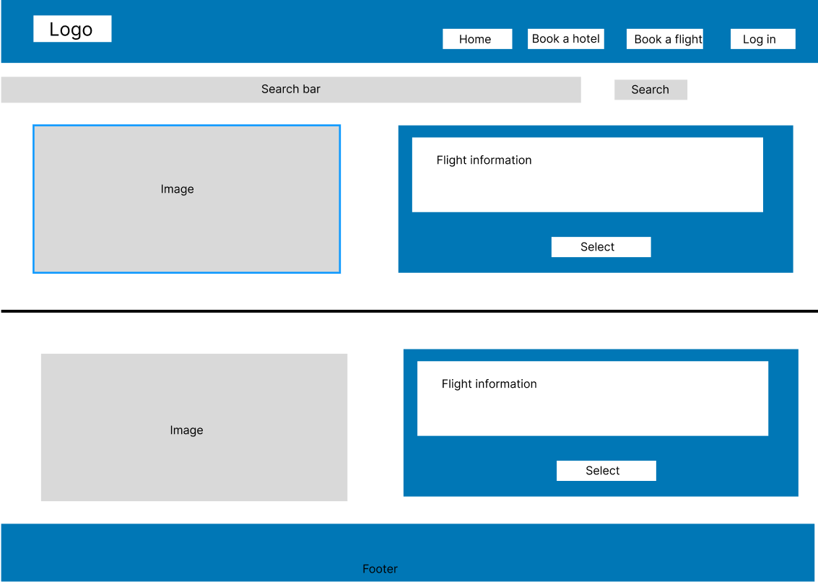

**Detailed flight page**

**Log in page**

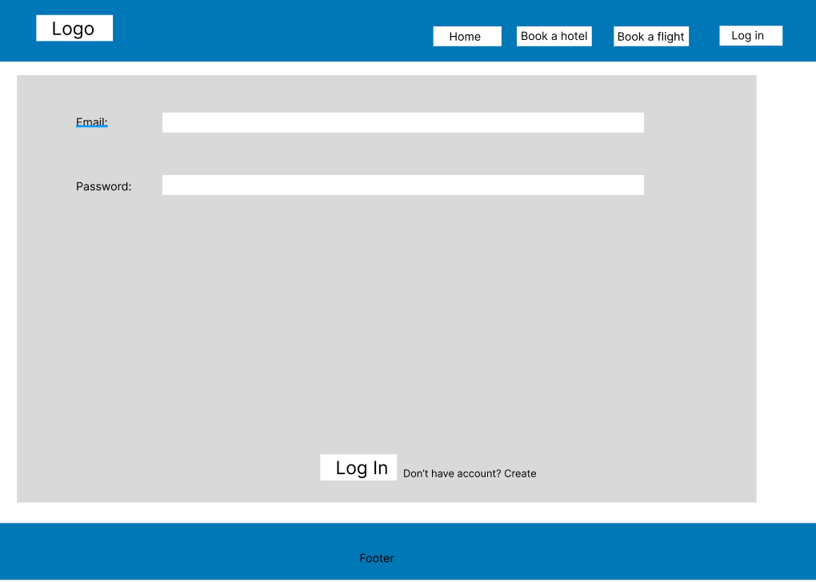

**Sign up page**

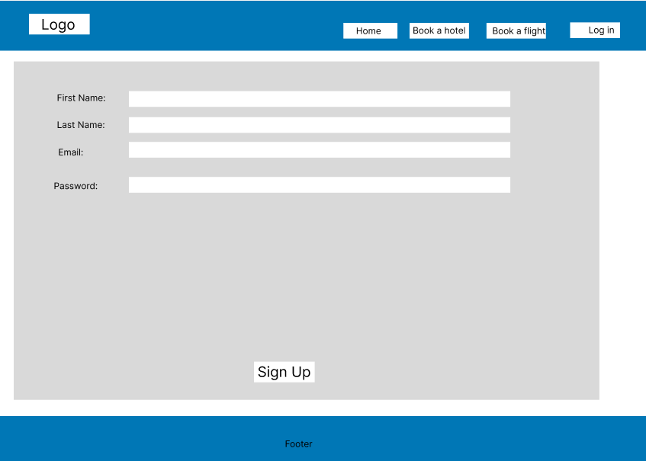

**Desktop application:**

**Main form:**

**Hotel section:**

**Add hotel:**

**Update hotel**

**Flight section:**

**Add flight:**

**Update flight:**

**Web application:**

**Home page**

**Hotel page**

**Hotel details page:**

**Flight page**

**Flight detail page:**

**Login page:**

**Register page:**

**User personal page:**

